Data Set :- Computer_Data

#Basic Stats Assignment 1

#Perform Basic Visualizations for all the columns(numerical data only) on any data set from data set folder make sure it has more data. So we can make better inferences for the visualizations (boxplot,histogram)

install.packages("readr")

library(readr)

Computer_Data<-read.csv("C://Users//Lenovo//Desktop//ExcelR//Assignments//Basic Statistics_Level 1//Computer_Data.csv")

View(Computer_Data)

hist(Computer_Data$price)

hist(Computer_Data$speed)

hist(Computer_Data$hd)

hist(Computer_Data$ram)

hist(Computer_Data$screen)

boxplot(Computer_Data$price,Computer_Data$hd)

boxplot(Computer_Data$speed,Computer_Data$ram)

Histogram Plots

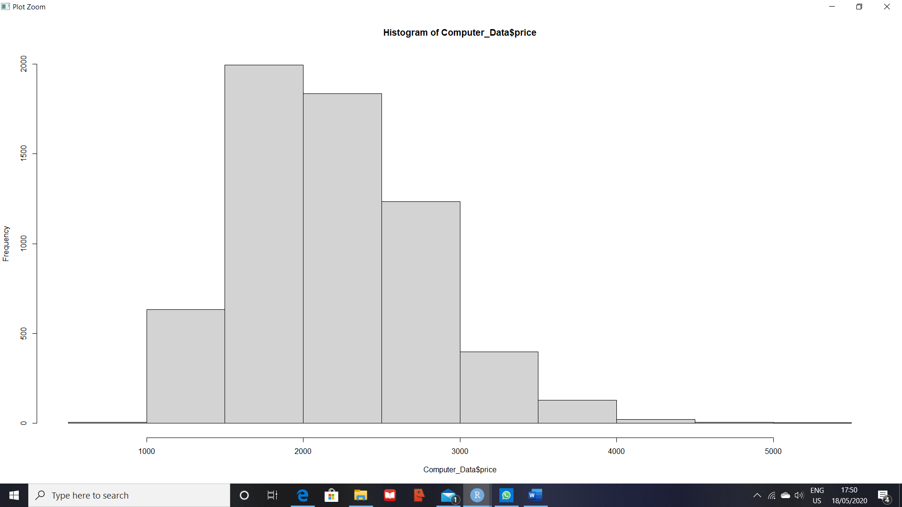

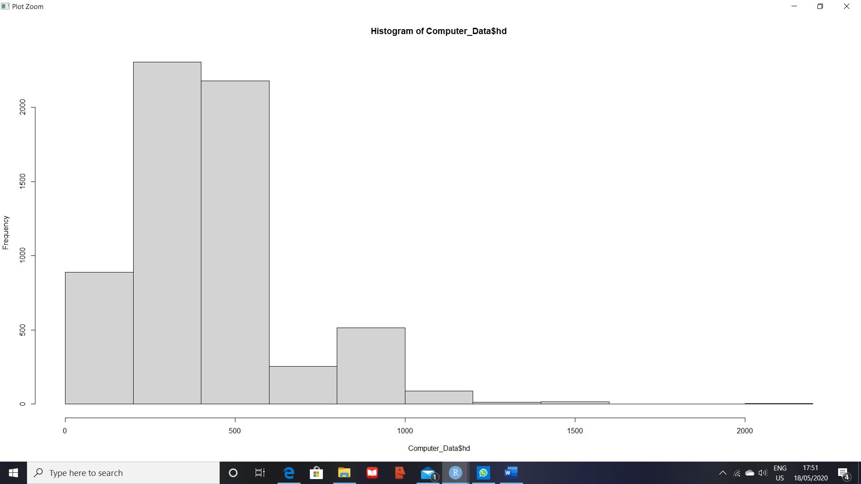

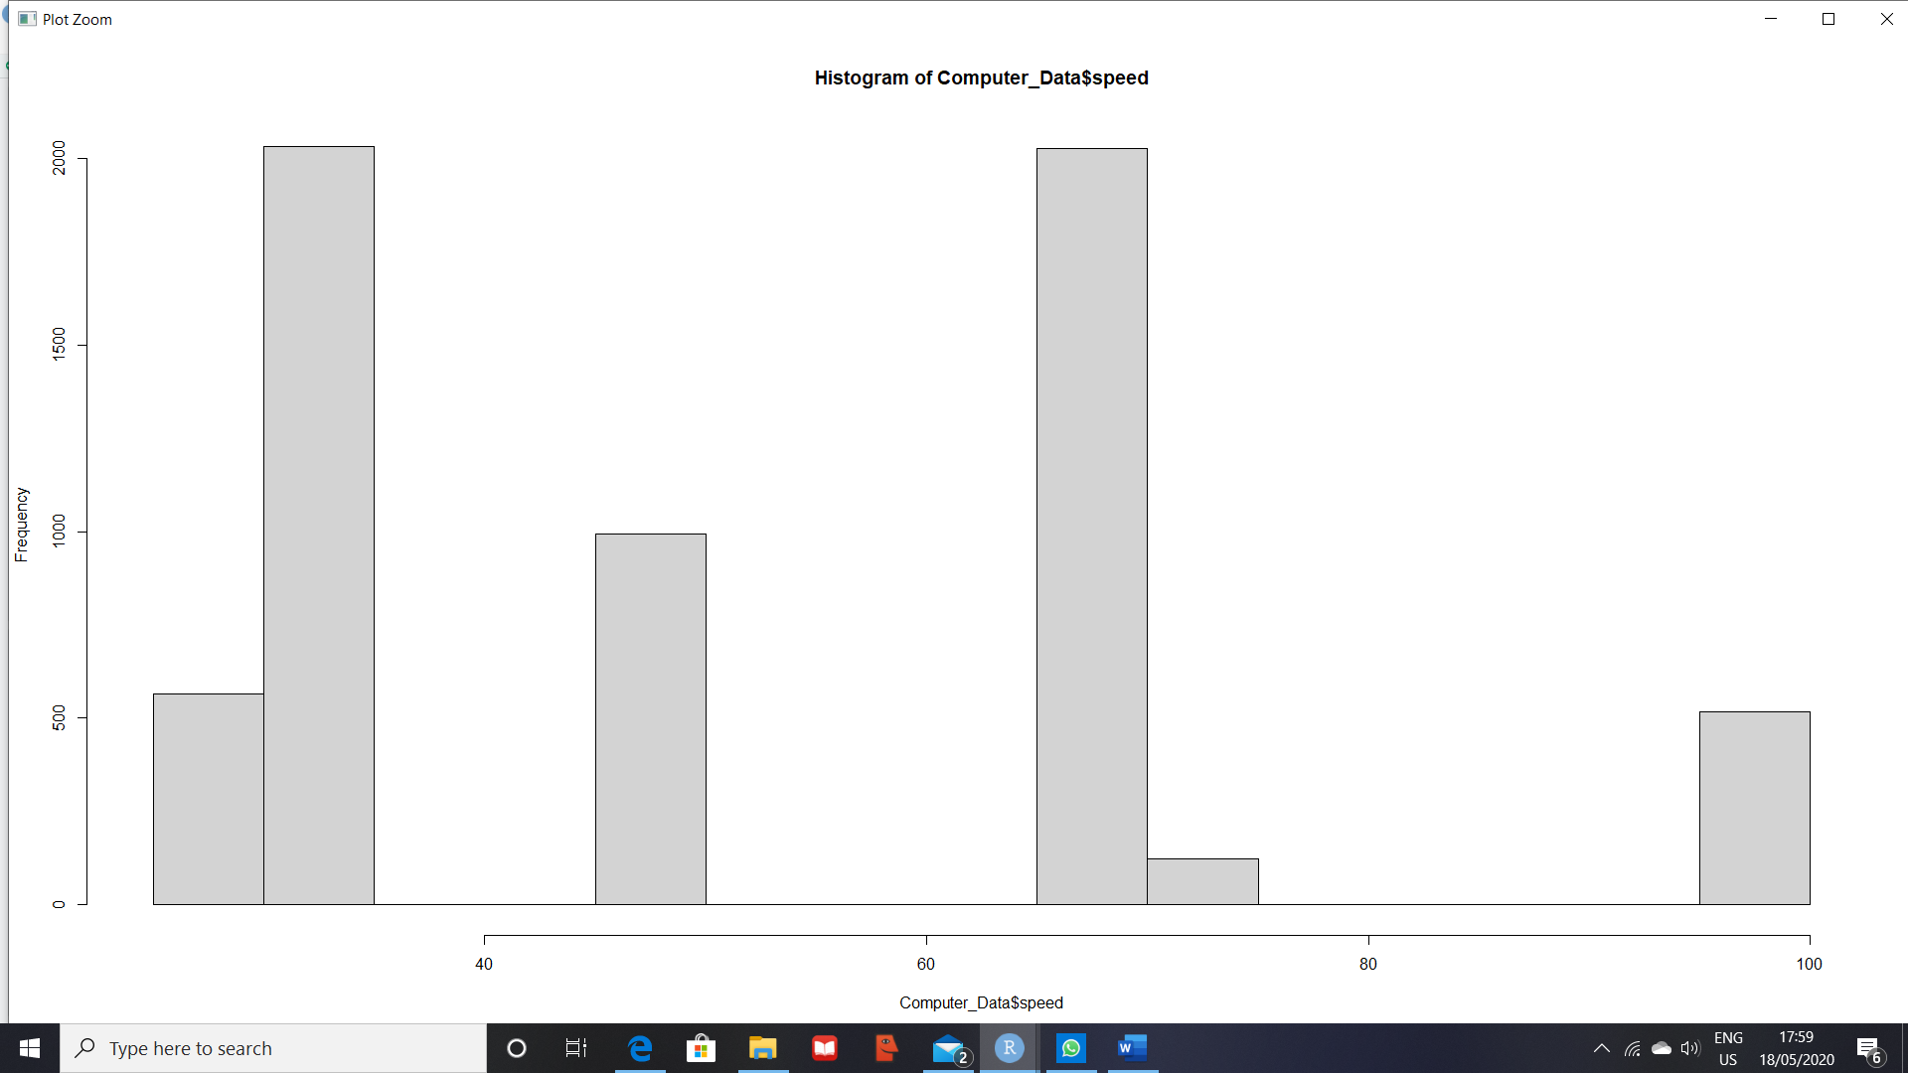

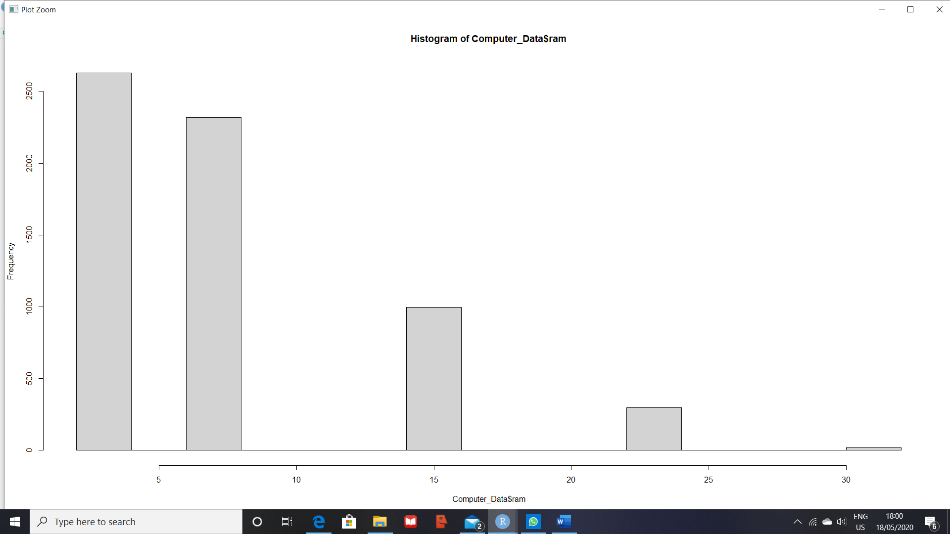

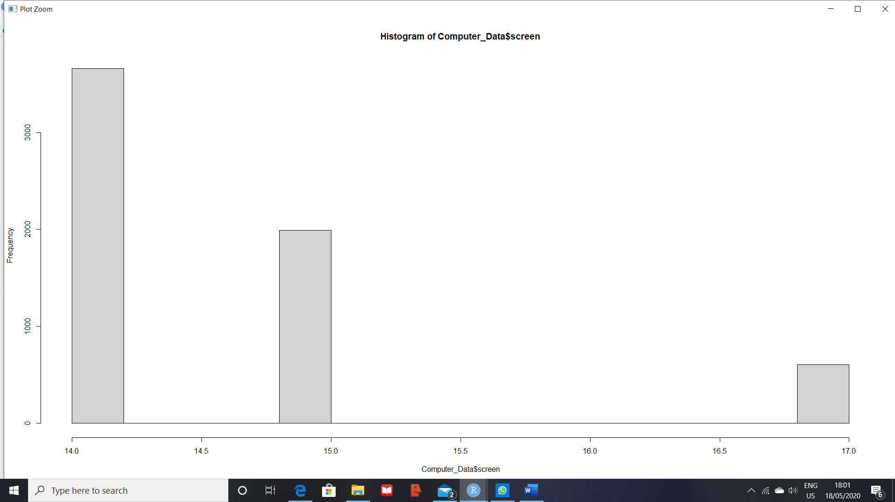

Multidirection Box Plot for Columns Price and hd

boxplot(Computer_Data$price,Computer_Data$hd)

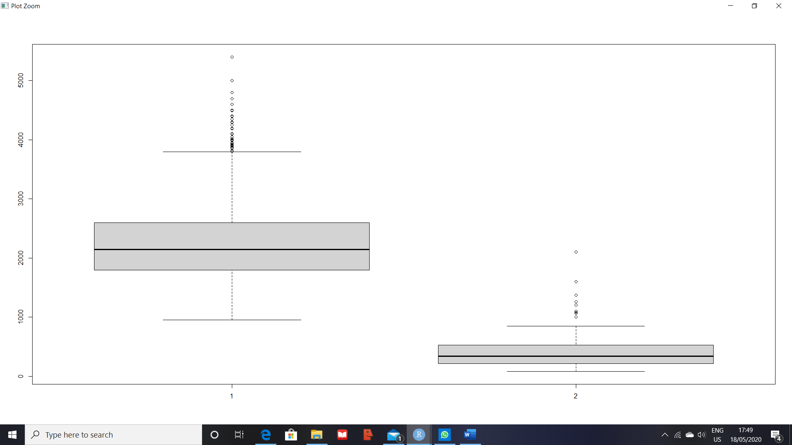

boxplot(Computer_Data$speed,Computer_Data$ram)

